1. **Introduction and Motivation**

Wherever a person goes to in a country with high population density areas, a parking issue will most likely be present. There is no difference in the case of Qatar as it is becoming more density populated, and one crowded place in the country is Qatar University (QU). Students in QU have started becoming more independent in their everyday life, and that involves driving a car. The number of students at QU owning a car is increasing drastically each year, not to mention the increasing number of students QU accepts each year, both of which have led to the demand for more parking spots. As Qatar University students, we are personally motivated to come up with a solution to this problem.

* 1. **Problem statement**

Over the past few years, the number of students in Qatar University (QU) has been steadily rising each year, which in turn has led to an increase in the number of vehicles arriving on the campus. According to the Ministry of Education statistics from 2012, the number of students attending QU exceeded ten thousand students [1] and is only increasing with each passing year. Likewise, the number of staff and faculty that need parking for their vehicles has also increased. Today, the number of students at Qatar University has reached more than 20,000 [2]. As a result, there has been a rapid increase in the number of people and vehicles on campus, and with the limited available parking spaces, parking problems are bound to exist. An online survey was shared with Qatar University students to assess the severity of the parking problem. As shown in Figure 1-1, 94.3% of the survey respondents believed that there is a real problem in finding a vacant parking spot inside the campus.

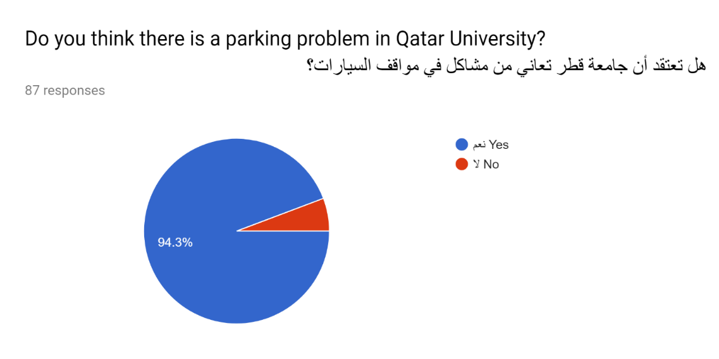

**Figure 1‑1: Statistics from Survey**

Frustrated students have taken to social media to air their criticism on the ongoing crisis of parking areas at Qatar University [3]. Students have circulated comments, pictures, and videos that represent their daily suffering due to the lack of parking spaces allocated to them in the university. Many sarcastic and critical tweets have discussed this issue, as displayed in Figures 1-2 until 1-5.

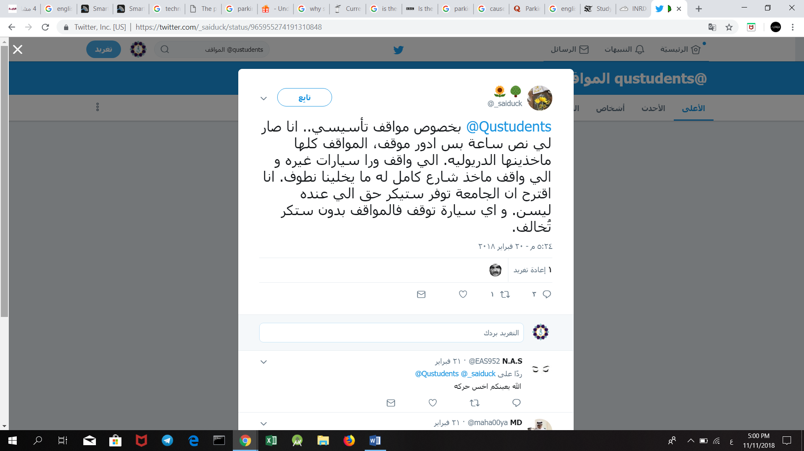

**Figure ‎1‑2: Tweet from Twitter about the parking problem**

**Figure ‎1‑3: Tweet from Twitter about the parking problem**

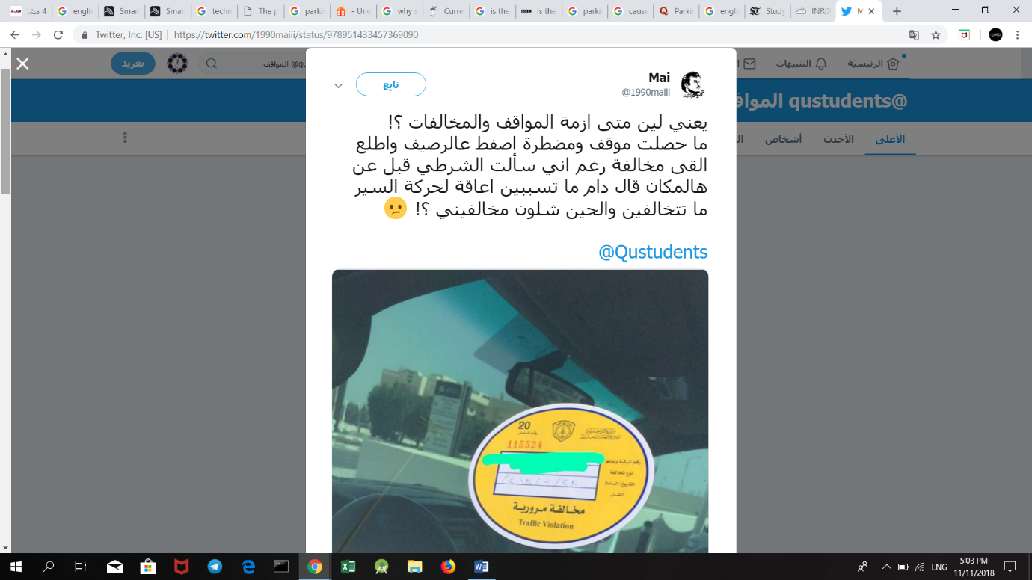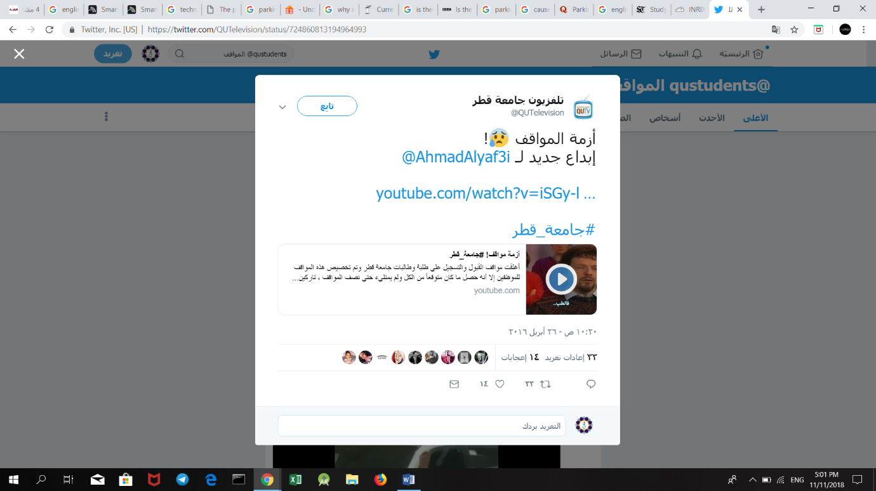



**Figure ‎1‑5: Tweet from Twitter about the parking problem**

**Figure ‎1‑4: Tweet from Twitter about the parking problem**

The problem has transcended student conversation to become the talk of the media in Qatar. Figures 1-6 up to 1-11 show headlines from prominent local newspapers (Al-Raya, Al-Watan, Al-Arab and Al-Sharq) that discuss the parking problem at Qatar University and its impact [4]. The articles made mention of the fact that the effects of this problem were not only limited to students and staff but also impacted the university’s visiting guests who come for events, ceremonies, seminars or conferences.

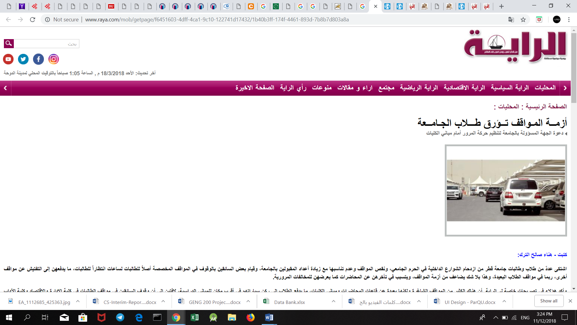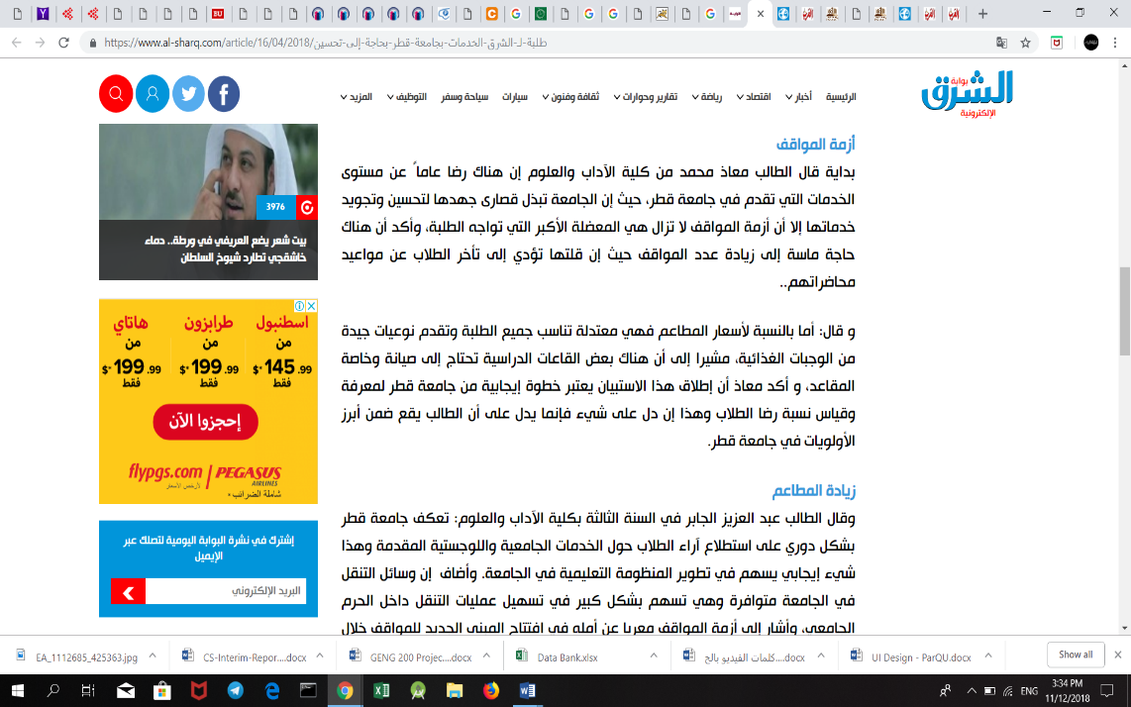

**Figure ‎1‑6: Article from Al-Sharq Newspaper**

**Figure ‎1‑7: Headline from Al-Raya Newspaper**

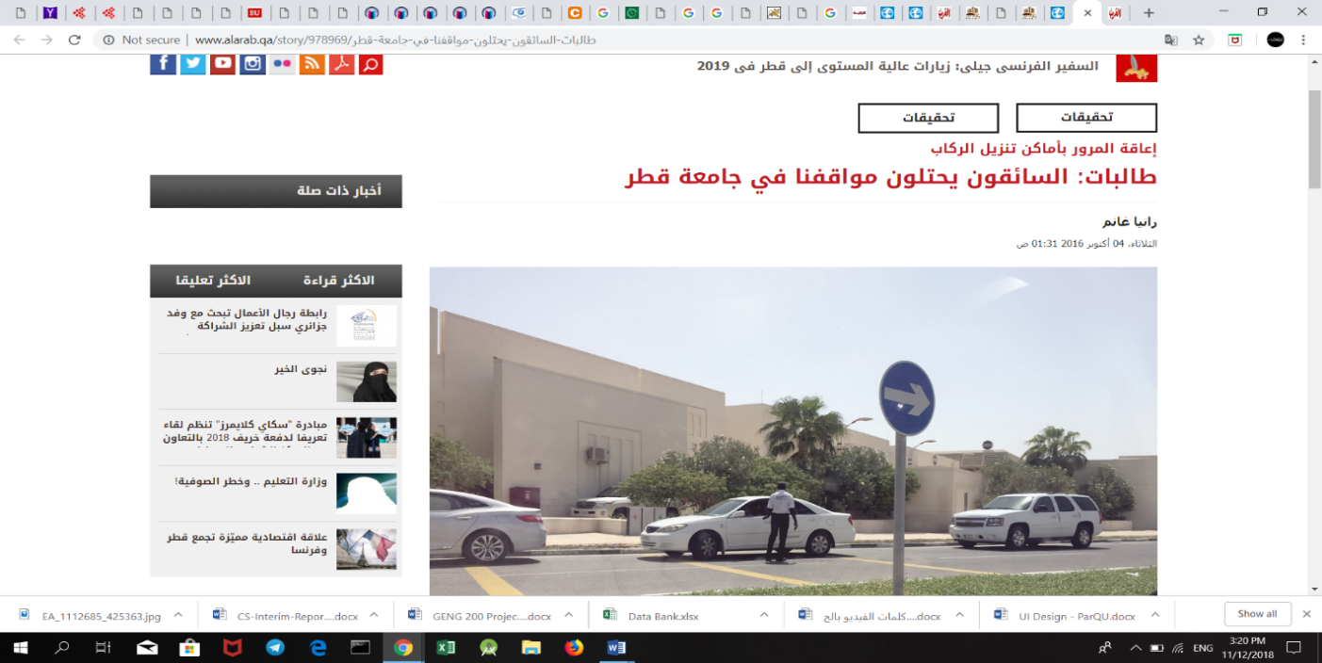

**Figure ‎1‑8: Headline from Al-Arab Newspaper**

**Figure ‎1‑9: Headline from Al-Arab Newspaper**

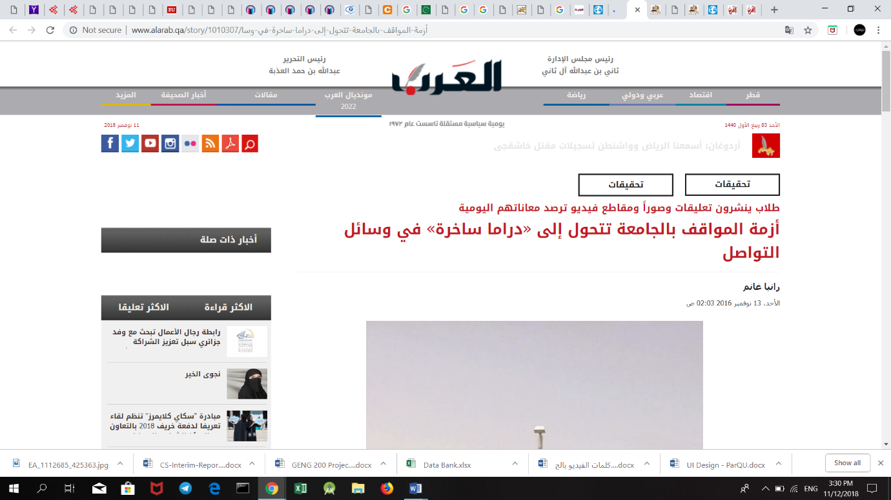

**Figure ‎1‑10: Headline from Al-Arab Newspaper**

**Figure ‎1‑11: Headline from Al-Watan Newspaper**

**Impact**

People looking for an empty parking spot constitutes one of the most significant causes of congestion, and wastes the time of students and staff. As shown in Figure 1-12, more than 60% of the students who responded to our survey reported that they take more than 15 minutes to find a vacant parking spot. To a student, 15 minutes late could mean being late for an exam or a quiz. Also, if the professor takes attendance at the start of the lecture, the student may be counted as absent. Further, Qatar University follows an attendance policy that states that a student automatically fails a course if he/she is absent for more than 25% of the class sessions. Hence, if the problem continues, it is possible that students will exceed the allowable absences and fail one of their courses. As a result, many students have declared that they are forced to come to the university early so that they can get a parking slot for their cars [5].

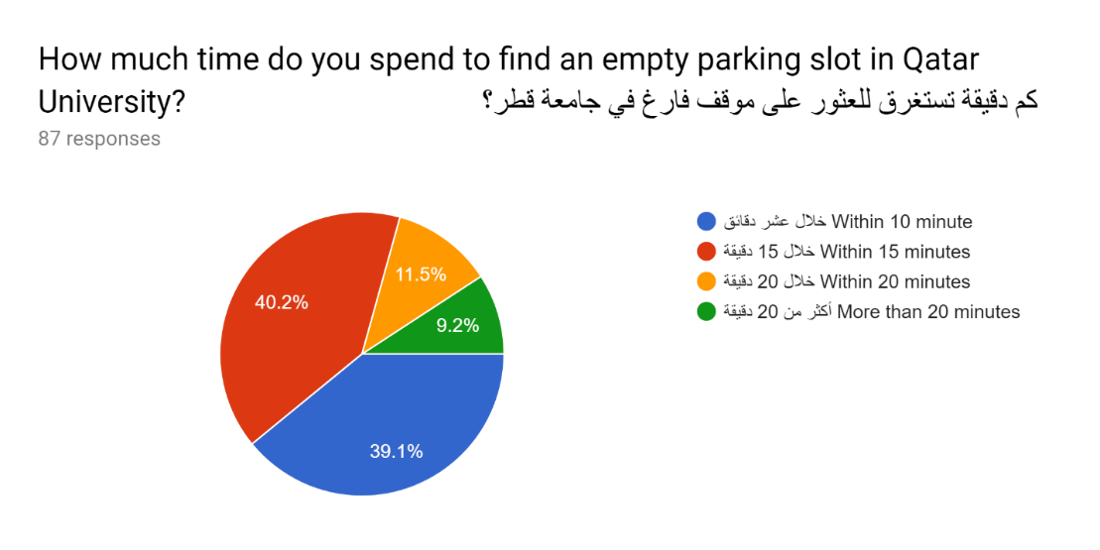

**Figure 1‑12: Statistics from Survey**

Even though people rarely notice or discuss the environmental impact, the parking problem creates environmental effects as it causes vehicles to consume more fuel while driving around to search for parking spots. This increase in fuel consumption wastes the vehicle owner’s money and leads to more CO2 emissions.

Additionally, hurried drivers are forced to park in illegal parking places which in turn leads to an increase in the number of traffic violations and accidents inside the campus. Figures 1-13 and 1-14 below show examples of illegal parking where cars are parked over sidewalks and on the grass field.

A truck on a city street

Description generated with high confidence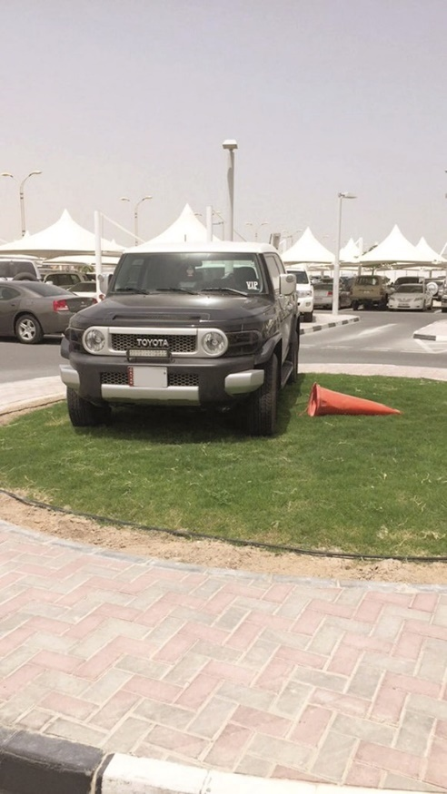

**Figure ‎1‑13: Vehicles in Qatar University parked illegally**

**Figure ‎1‑14: Vehicles in Qatar University parked illegally**

In the end, the university’s reputation is negatively affected by this situation, because it is the first thing that guests see when visiting and that students and staff notice when they start their day.

* 1. **Project significance**

A parking system is needed to organize and utilize the parking area resources. An adequate parking system would be able to guide the vehicle owners at the university in such a way as to reduce traffic overcrowding by suggesting different routes along the campus roads. Such a system could reduce the vehicle owner’s search time significantly by providing such information. As a result, traffic congestion would decrease and the university would be able to fine vehicle owners when they park illegally.

A smart parking system would not only be beneficial for anyone entering the campus of Qatar University but would also be considered valuable for the environment [6][7]. The environment is more protected by the decreased CO2 emissions from cars that would reduce the level of pollution [6]. Also, for the security and other monitoring staff, the data gathered via the implementation of the parking system could be used to predict future parking patterns. Strategies for setting fines and parking fees could also be manipulated based on the information gained to increase the university’s profit.

* 1. **Project objectives**

1. To design and implement a system that can manage parking areas.

2. To use sensors (Ultrasonic Sensor and RFID Reader) to collect data.

3. To use microcontroller boards (Arduino) to receive data from used sensors and send it to a database (Firebase) for storage.

4. To design an Android application and a website.